How to Print Large Image on Multiple Pages in Windows
You need to go through a couple of options in order to print image on multiple pages using the split print feature. This feature will work on almost any Windows operating systems (from Windows XP to Windows 10), so if you are using Windows operating systems on your computer you can follow below-explained tutorial of how to print a large image on multiple pages in Windows. Here’s how:
Step (1): First of all, open the poster or image which you want to print. You have to open the photo in Paint and not in any other software.
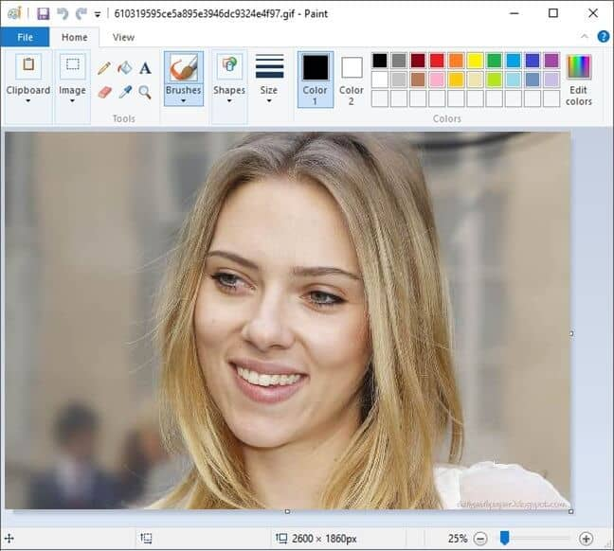
Step (2): Once the poster or image is opened in Paint, you have to select the Print and then Page setup option. If you are using Windows XP you need to select “File” and then open “Page setup” from there.
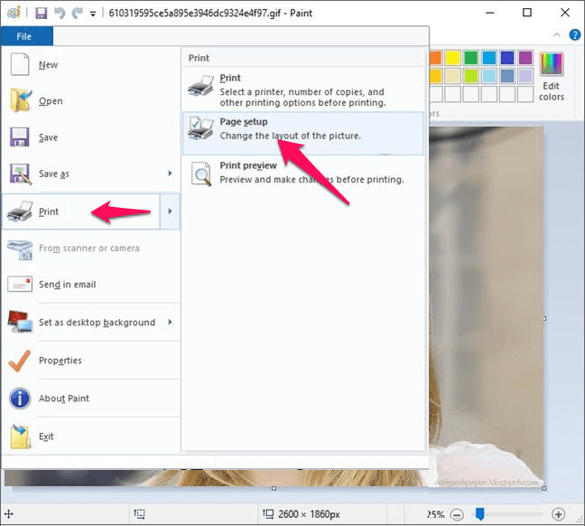
Step (3): Now, go to the Scaling section choose Fit to option. In the Fit to pages box, you have to set the number of pages according to your need (2 by 2 page (s), 4 by 2 page (s), or whatever you need).
For the example: Here we are entering 3 by 3 page (s).
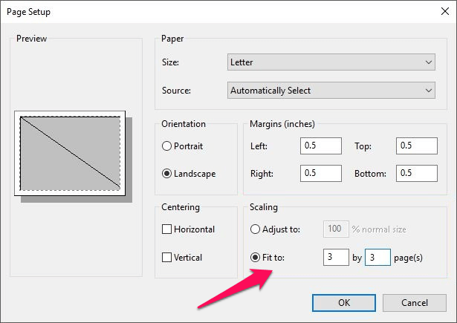
You can alter the setting as per your requirement i.e. the number of pages on which you want to get your poster.
Step (4): Once you have made the page changes under Fit to option, simply click on OK button.
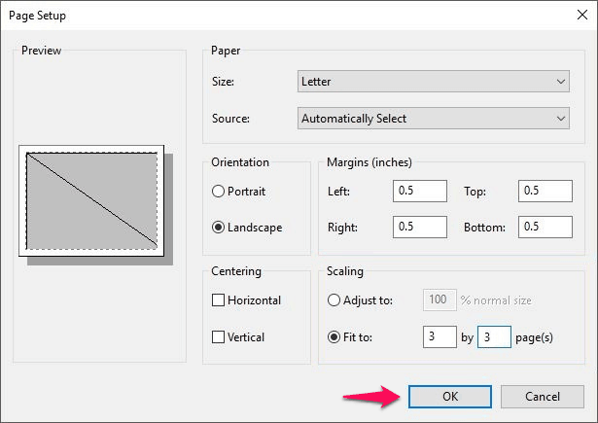
Step (5): Now give the print command using Paint and make sure that you select All pages under the Page Range section.
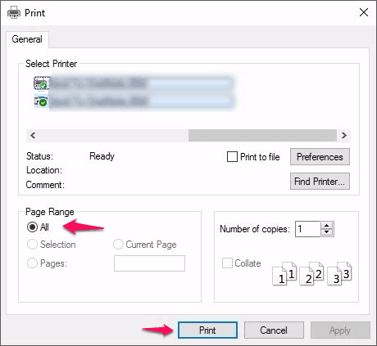
Step (6): If you perform all the steps correctly, you will be able to print image on multiple pages as shown below [Final result of entering 3 by 3 page (s)]:
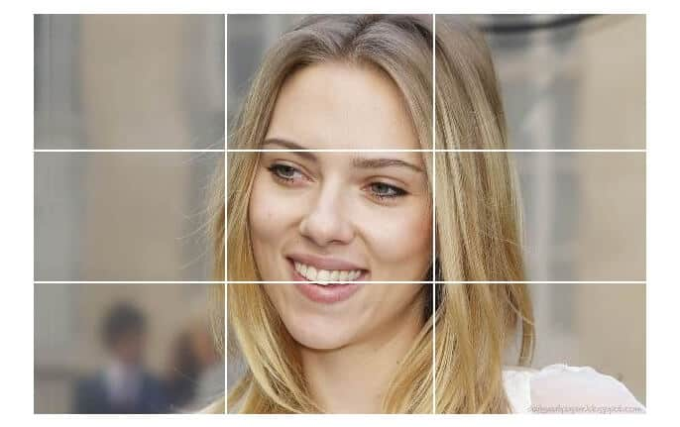
This completes our tutorial of how to print a large image on multiple pages. Now, you can take the printout of big posters using this method. You can also adjust margins of the pages by opening the Page setup menu. Once you have got all the printouts you can stick them together using the scotch tape and get the complete poster.

