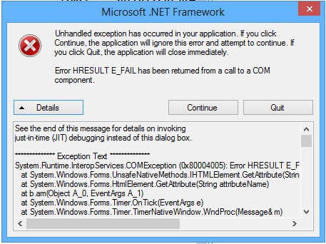
See the end of this message for details on invoking
just-in-time (JIT) debugging instead of this dialog box.

************** Exception Text **************
System.Runtime.InteropServices.COMException (0x80004005): Error HRESULT E_FAIL has been returned from a call to a COM component.
at System.Windows.Forms.UnsafeNativeMethods.IHTMLElement.GetAttribute(String attributeName, Int32 lFlags)
at System.Windows.Forms.HtmlElement.GetAttribute(String attributeName)
at b.am(Object A_0, EventArgs A_1)
at System.Windows.Forms.Timer.OnTick(EventArgs e)
at System.Windows.Forms.Timer.TimerNativeWindow.WndProc(Message& m)
at System.Windows.Forms.NativeWindow.Callback(IntPtr hWnd, Int32 msg, IntPtr wparam, IntPtr lparam)

************** Loaded Assemblies **************
mscorlib
Assembly Version: 2.0.0.0
Win32 Version: 2.0.50727.6407 (Win8RTMGDR.050727-6400)
CodeBase: file:///C:/Windows/Microsoft.NET/Framework64/v2.0.50727/mscorlib.dll
----------------------------------------
Vagex
Assembly Version: 2.0.3.0
Win32 Version: 2.0.3
CodeBase: file:///K:/Vagex/Vagex.exe
----------------------------------------
Microsoft.VisualBasic
Assembly Version: 8.0.0.0
Win32 Version: 8.0.50727.6387 (Win8RTM.050727-6300)
CodeBase: file:///C:/Windows/assembly/GAC_MSIL/Microsoft.VisualBasic/8.0.0.0__b03f5f7f11d50a3a/Microsoft.VisualBasic.dll
----------------------------------------
System
Assembly Version: 2.0.0.0
Win32 Version: 2.0.50727.6401 (Win8RTMGDR.050727-6400)
CodeBase: file:///C:/Windows/assembly/GAC_MSIL/System/2.0.0.0__b77a5c561934e089/System.dll
----------------------------------------
System.Windows.Forms
Assembly Version: 2.0.0.0
Win32 Version: 2.0.50727.6402 (Win8RTMGDR.050727-6400)
CodeBase: file:///C:/Windows/assembly/GAC_MSIL/System.Windows.Forms/2.0.0.0__b77a5c561934e089/System.Windows.Forms.dll
----------------------------------------
System.Drawing
Assembly Version: 2.0.0.0
Win32 Version: 2.0.50727.6401 (Win8RTMGDR.050727-6400)
CodeBase: file:///C:/Windows/assembly/GAC_MSIL/System.Drawing/2.0.0.0__b03f5f7f11d50a3a/System.Drawing.dll
----------------------------------------
System.Runtime.Remoting
Assembly Version: 2.0.0.0
Win32 Version: 2.0.50727.6387 (Win8RTM.050727-6300)
CodeBase: file:///C:/Windows/assembly/GAC_MSIL/System.Runtime.Remoting/2.0.0.0__b77a5c561934e089/System.Runtime.Remoting.dll
----------------------------------------
Interop.SHDocVw
Assembly Version: 1.1.0.0
Win32 Version: 1.1.0.0
CodeBase: file:///K:/Vagex/Interop.SHDocVw.DLL
----------------------------------------
System.Configuration
Assembly Version: 2.0.0.0
Win32 Version: 2.0.50727.6408 (Win8RTMGDR.050727-6400)
CodeBase: file:///C:/Windows/assembly/GAC_MSIL/System.Configuration/2.0.0.0__b03f5f7f11d50a3a/System.Configuration.dll
----------------------------------------
System.Xml
Assembly Version: 2.0.0.0
Win32 Version: 2.0.50727.6408 (Win8RTMGDR.050727-6400)
CodeBase: file:///C:/Windows/assembly/GAC_MSIL/System.Xml/2.0.0.0__b77a5c561934e089/System.Xml.dll
----------------------------------------
CustomMarshalers
Assembly Version: 2.0.0.0
Win32 Version: 2.0.50727.6387 (Win8RTM.050727-6300)
CodeBase: file:///C:/Windows/assembly/GAC_64/CustomMarshalers/2.0.0.0__b03f5f7f11d50a3a/CustomMarshalers.dll
----------------------------------------
Microsoft.mshtml
Assembly Version: 7.0.3300.0
Win32 Version: 7.0.3300.0
CodeBase: file:///C:/Windows/assembly/GAC/Microsoft.mshtml/7.0.3300.0__b03f5f7f11d50a3a/Microsoft.mshtml.dll
----------------------------------------

************** JIT Debugging **************
To enable just-in-time (JIT) debugging, the .config file for this
application or computer (machine.config) must have the
jitDebugging value set in the system.windows.forms section.
The application must also be compiled with debugging
enabled.

For example:

<configuration>
<system.windows.forms jitDebugging="true" />
</configuration>

When JIT debugging is enabled, any unhandled exception
will be sent to the JIT debugger registered on the computer
rather than be handled by this dialog box.

