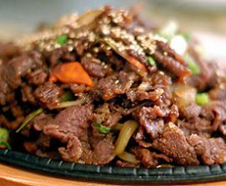
Bul-go-gi
Grilled Marinated Beef

Bulgogi is one of Korea's most popular beef dishes that is made from thinly sliced sirloin or another prime cut of beef (rib eye). It is usually marinated in a mixture of soy sauce, sesame oil, black pepper, garlic, onions, ginger, and sugar for two to four hours to enhance the flavor and its tenderization. Bulgogi is traditionally grilled but broiling or pan-cooking is common as well. Whole cloves of garlic, sliced onions, and chopped green peppers are often grilled or cooked at the same time. It is often served to non-Koreans as a first taste of Korean cuisine.
This dish is usually served with a side of lettuce, spinach, or other leafy vegetable, which is used to wrap a slice of cooked meat, often times along with a dab of ssamjang, kimchi, or other side dishes, and then eaten as a whole. To see a visual illustration, click here.
Korean 101: Bul is the Korean word for fire and gogi is meat, therefore, it translates into fire meat. However, it's not quite spicy in taste but somewhat on the sweet side.
Recipe Ingredients
1 lb thinly sliced beef (sirloin or rib eye)
5 tbsp sugar
½ cup soy sauce
2 buds finely chopped garlic (can be crushed but remove buds before serving)
¼ tsp salt
5 tbsp Mirin (sweet sake, optional)
2 tbsp sesame oil
2 tbsp toasted sesame seeds
1 cup split green onions
2 cups thinly sliced carrots (optional)
Cooking Directions
Mix all ingredients except carrots. Marinate in refrigerator for at least 2 hours.
Cook over medium high heat until meat is just short of desired completion.
Add carrots and cook for an additional 3 minutes.
Serve with rice.

