Crete, Rethymno

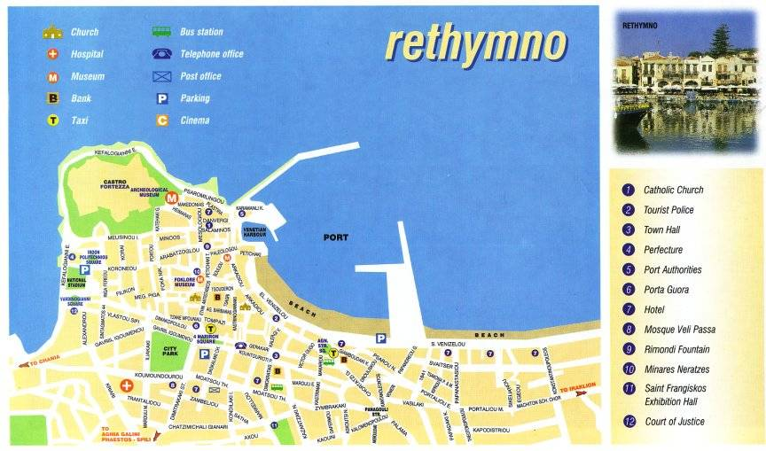

Ancient sites in West Crete
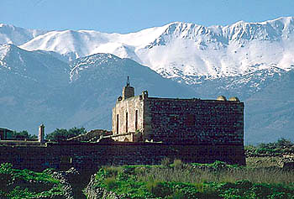
Crete is a very old place, with layer upon layer of civilization, and accordingly there are many ancient sites all over the island. You will not find many Minoan remains in West Crete, at the most a few walls here and there (for example in Kanevaro St. in Chania where you can see the excavations of four Minoan villas).
Roman and Hellenistic ruins are more widespread but few excavations have been conducted, meaning that most ancient sites do not offer much to see to the visitor. The following places are however worth a visit.

Aptera
Situated above the bay of Souda, east of Chania, Aptera used to be a very large city . It was founded by the Mycenaeans (although there is evidence of late Minoan civilization), enlarged by the Dorians and was used as a settlement until the Byzantine period. The area covered by Aptera is very large and only a few excavations have taken place so far. The ruins are from different periods: enormous Roman cisterns, foundations of a Demeter temple, a Dorian temple, a Hellenistic Apollo temple are interspersed with a Byzantine cloister and a large Turkish castle.
The view from Aptera is worth the journey: to the north (from the castle) you can see the whole of the Souda bay and to the south the White Mountains.
Falassarna

Situated about 55 km west of Chania, Falassarna is best known for its nice beach and very clean sea. To the north of the beach (10 minutes on foot), you can see the remains of an ancient harbour dating back to the late Minoan period. The settlement was inhabited during the Hellenistic and Roman period and was probably abandoned when the island moved upwards by several meters. The harbour is now almost 6 meters above the sea level.
There is an interesting "throne" (its function is unclear) and a sarcophagus in its vicinity. A little further to the north are the remains of a quarry (it was first thought to be a harbour basin), a round tower and the remains of houses. These are being excavated at the moment. It is also worth walking up the hill, through barely visible remains of houses. At the top there is a little platform with a lovely view.

Polirinia
Situated about 6 km inland from Kastelli, above the village of Polirinia, the Dorians had built a large town in the 6th century BC on top of a steep hill. Kissamos (the present day Kastelli) was its harbour. There is not much left from the ancient town - only a few walls, some graves and the ruins of temples - overshadowed by the ruins of a Venetian castle - but it is really worth a visit because of the splendid panoramic view of the whole gulf of Kissamos. There is a very pleasant taverna just below the archaeological site and the view from its terrace beats most places in West Crete, especially at sunset.

Minoan necropolis of Armeni
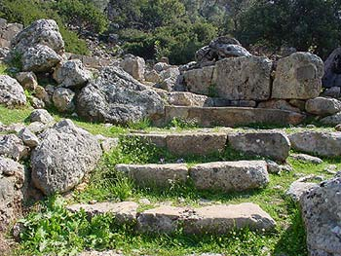
Western Crete was inhabited in Minoan times but does not possess any large Minoan archaeological sites such as the palaces of Knossos, Phaestos and Zakros in central and east Crete or at least, none have been unearthed so far.
One site of interest is the Minoan necropolis of Armeni, about 9 km from Rethymnon. It was discovered by accident some decades ago and is still being excavated. Until now, about 200 underground burial chambers have been discovered.

Lissos
Situated about one hour by foot to the west of Sougia, Lissos was an important coastal settlement inhabited through the Hellenistic, Roman and Byzantine periods. Lissos was famous for its healing spring. There are a number of ruins to be seen, especially the small Asklepios (the Greco-Roman god of healing) temple which was famous throughout the region. You can still see a well preserved mosaic floor in it. The whole area is full of ruins, many of them hidden by the vegetation.
On the western side of the valley of Lissos are about 20 small houses with arched ceilings covered in red roof tiles which are supposed to be Roman graves.

Museums of West Crete

Archaeological Museum Chania
Housed in the former venetian church of San Francesco, this small museum is well-worth visiting. It houses objects from the Neolithic and Minoan to late Roman periods found in the prefecture of Chania.
Halidon St. Chania
Opening times: Tuesday - Friday 8-19h Saturday-Sunday 8.30-15h Monday closed

Nautical Museum Chania
Everything nautical and a beautiful seashells collection as a bonus. The museum is located at the north-east end of the Venetian harbour.
Opening times: Monday - Saturday 10-16h Sunday closed

Historical Museum and Archive
This small museum covers the more recent history of Crete.
Sfakianakis St. 20
Opening times: Monday - Saturday 10 - 16h

Byzantine and Post-Byzantine Collection
A small museum showing mosaics, funerary inscriptions, wall-paintings, icons, architectural sculptures, ceramics and items of minor arts, and coins.
Theotokopoulou Str. 82 Chania
Monday: Closed Tuesday-Sunday: 08.30-15.00

Archaeological Museum Rethymnon
Located in a Turkish building, this museum shows objects from the Neolithic to Roman period found in the prefecture of Rethymnon. Many Minoan objects were found on hilltops sacred sites, in caves and necropolis.
Opposite the entrance of the fortezza. Opening times: Tuesday - Sunday 8.30 - 15h Monday closed

Archaeological Museum Heraklion
This museum is not in West Crete but if you come to Crete, it is almost a sin not to go to Heraklion to visit it. It houses the most important collection of Minoan objects and frescoes in the world. The museum gets very crowded during the tourist season but is still a must.
Plateia Eleftherias
Opening times: Tuesday Sunday 8 -18.00 Monday 12.30 - 18.00

Cities of West Crete - Chania and Rethymnon

Rethymnon
Rethymnon is a little smaller than Chania but is also growing quickly into a sprawling, rather ugly urban centre. However its old town and narrow alleys along the water front compete with Chania for the title of "Most beautiful city of Crete".
There are more Turkish houses and minarets remaining here than in Chania, although most houses are of Venetian origin. Rethymnon also has a long sandy beach which starts practically in the centre of the town and stretches eastward. Needless to say, this beach is lined with hotels, restaurants, cafes and all the other accompanying touristic "symptoms".

Chania
Chania is said to be the oldest, still inhabited city in the world. It may or may not be right but a fact is that Chania has been in existence for over 5000 years. It is now a large, noisy town but as soon as you get into the old town and walk its narrow streets and alleys the atmosphere changes and becomes charged with history.
Most prominent are the Venetian buildings and fortifications as well as the covered market.
Chania also houses an Archaeological Museum and a Maritime Museum which are both worth a visit.
Chania offers good opportunities for shopping, nice cafés and lots of good restaurants.

Churches, chapels and monasteries in West Crete

Byzantine churches and chapels
There are hundreds, if not thousands, of Byzantine churches and chapels on Crete. Some are over a thousand years old and many still house beautiful frescoes. The only really famous Byzantine church is the Panagia Kera (in eastern Crete) so that most of the others can still be visited in relative peace. Nowadays, most of these chapels and churches are kept locked and you will often have to hunt for the key in the village. Your best starting point is in the "kafeneion" where someone is bound to know its whereabouts. Please avoid asking for the key at "unsocial times" such as in the early afternoon where many people take a nap.
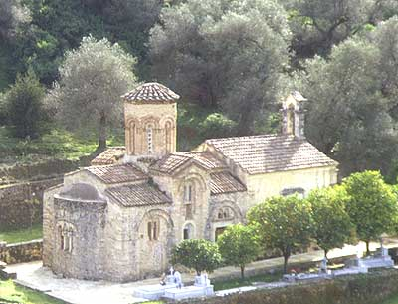
Take a look at Wall paintings in Crete for a nice introduction to Byzantine frescoes.

Monasteries

Crete has a number of large monasteries. Monastic life has lost its appeal and only have a few monks (or nuns) still live in them. Below you can see the most famous monasteries in West Crete. There are many more .

Agia Triada, Gouverneto and Katholiko
Collectively known as the monasteries of Akrotiri they spread over a large area on the northern part of the Akrotiri peninsula, east of the city of Chania. Agia Triada used to be an important religious school and has enough space for several hundred monks, nowadays only 3 or 4 live there.
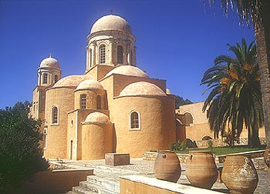
The ruined monastery of Katholiko which can only reached on foot is probably the oldest monastery in Crete (11th century?) and its ruins are very impressive, with a huge bridge still in perfect condition spanning a riverbed.

Preveli monastery

The monastery of Preveli is superbly located above the Libyan sea and also has a rich history of resistance against the Turks (who set fire to it) as well as the Germans during W.W.II (they plundered it in retaliation for helping the defeated Allied troops leave the island).
Beautiful church and interesting little museum.

Arkadi monastery

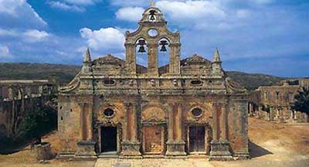
The 16th century monastery of Arkadi is located 22 km south-east of Rethimnon and posses an impressive Venetian baroque church building. Its main claim to fame is however of more historical nature: in 1866, the Turks sent massive forces to quell insurrections on the island. Hundreds of men, women and children fled their villages and took shelter in the monastery. When 2000 Turkish soldiers attacked the building, rather than surrender, the Cretans set alight a store of gunpowder. The explosion killed almost everyone, Turks included.
Arkadi remains a symbol of Cretan defiance against those who want to subdue them.

Top nature spots in West Crete

The gorge of Samaria
The gorge of Samaria is one of the biggest tourist attractions in Crete. Over 250.000 people visit it every year! Still interested and willing to brave the crowds? Then visit The gorge of Samaria for details, maps and photos.

The White Mountains
The White Mountains or Lefka Ori is the largest mountain range in Crete, with over 30 summits above 2000m and cut by about 50 gorges. They are the dominant feature of West Crete and a must for every nature lover, offering innumerable walks and excursions. There are plenty of photos in the Photos section of this site

Omalos plateau
Famously known because it is the starting point for the walk through the Samaria gorge the Omalos plateau is worth more than a cursory glance. It is also the starting point of many beautiful mountain walks, a place for the inhabitants of Hania to see the snow in winter and for all to cool off in summer.

Anopolis plateau
This is a really special place: a large plateau, its boundaries defined by the White Mountains to the North and plunging towards the Libyan sea to the South, it is maybe the heart of Western Crete, having never been invaded by the Turks. It is still a place of strong traditions and village life. The nature is really beautiful, there are a lot of interesting walks, abandoned villages and ancient chapels.

Imbros gorge
The walk through the gorge of Imbros is a popular alternative to the Samaria gorge for those who prefer a shorter walk. It is also far less crowded (but by no means empty!).
The gorge of Imbros is also used by individuals and tour organizers as an alternative to the Samaria gorge when this one is closed to the public , generally between October and the beginning of May.

Amari valley
The Amari valley, south-east of Rethimnon is the heartland of Crete. Located between Mt. Psiloritis and Kedros, it harbours around 40 unspoilt villages set amid a lush landscape.
You will need your own transport to visit the area as the public transport network is not well developed.

Argiroupolis
Situated in the hinterlands of Rethimnon, Argiroupolis is the perfect place to escape from the heat in the summer. The lower village is a watery oasis formed by mountain springs. Running through aqueducts, washing down walls, seeping from stones and pouring from spigots, the gushing springwater supplies the entire city of Rethimnon.
The luxuriant vegetation, the shade and the coolness of the springs make it the perfect spot for lingering over lunch in one of the local tavernas.
Argiroupolis is built on the remains of the ancient city of Lappa and there is plenty to explore.

Kournas Lake
Kournas lake may not be as exotic to foreign visitors as it is to the Cretans for whom it is the only sweet water lake on the island.
Located 3 km inland from Georgioupolis, at the foot of the White Mountains, its atmosphere is more reminiscent of Switzerland than Crete.
The clear water is great for swimming and constantly changes colour according to the weather and time of the day.
Rethymno is one of the four prefectures of Crete, stretching from the 'White Mountains' to 'Mount Psiloritis' and bordered by the the prefectures of Chania and Heraklion. It covers and area of 1,496km² and has a population of just over 81,000. The mountain ranges of the 'White Mountains', Psiloritis, Kouloukounas, Kedros, Asiderotas, Vryssinas form a network of valleys which delight every visitor and provide plenty of places to explore and thing to see.
The prefecture of Rethymno has a total of 263 villages with an average inhabitancy of 200. Officially classed as semi-mountainous, 507km² are cultivated, 936km² are are covered by settlements and the remaining 17km² by forest. The largest forest can be found near the Armeni Village (oak trees), Aghios Ioannis and Agiou Vassiliou (Cypress). Kouloukounas and south of the Arkadi Monastrey (Thorn-Oak Trees).
The university town of Rethymno with it's 23,000 inhabitants is the capital of the prefecture is located centrally on the North coast of the island is a vibrant and historically interesting holiday destination. The Venetian fortress overlooking the many Turkish minarets reflects the turbulent history of this ancient town. Rethymnon being destroyed in 1567 when Algerian pirates conquered, robbed and burned it, the Turks taking over in 1646.
Rethymno, the third largest town in Crete offers something for everyone. Disco music bars, archaeological museums, historical and folk museums, and a centre for contemporary art. Countless tavernas and restaurants line the picturesque streets and harbour in the old town area. It is also a paradise for shopaholics with so many small shops offering a wide variety of products to take home.
The Thursday market in the main square is always fun as are the bustling stalls that line Andistasis street, selling craft items and locally-produced foods.
The sandy beach stretches for kilometres with every facility available, tavernas, car hire, supermarkets etc.
For the athlete, the beach offers parasailing, jet skis, banana rides and pedalos. The less energetic can just relax and watch all the fun from a safe distance.
Leaving the old town through the Porta Guora archway will take you to the towns main square which is overlooked by a marvellous church. Well worth a visit to admire the decoration and architecture. Visitors are welcome but are expected to dress respectfully i. e. not beach clothes.
Almost opposite the main square are the public gardens where one can stroll in the cool under the shade of huge palms, eucalyptus, and many other tree varieties. There is also an outdoor cafe where one can sit and watch the world go by. The gardens also have a children's zoo, small but it may entertain the children for a while. The last two weeks in July the annual wine festival is held here. For a small admission fee drink all the free wine you can manage whilst watching the traditional entertainment of folk music and dancing.
To the west of the town about half a kilometre from the main square is the bus station where you can get a bus to local places of interest.
There are lots of "hole in the wall machines" in Rethymno from which you can obtain local currency. Machines can be found connected to the Visa, Cirrus, Maestro. Eurocard, etc. UK and worldwide banking networks.

